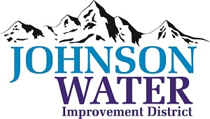
3748 West Highway 87
Roosevelt, UT 84066
Phone (435) 722-2620
June 18, 2026

SUBJECT: Regular Board Meeting

The Board Meeting is Thursday, June 18, 2026 @ 6:30 pm.
Agenda:
- Minutes ~ April and May 2026
- Financial ~ April and May 2026

- Appointments:

  - Aycock Miles & Associates
- 2025 Audit

  - Sunrise Updates on Construction Projects
- Prequalification Contractors
- East System Improvement Easement Progress

  - Jones & DeMille
- Ioka

- Rate Increase

- Energence Utah Water Availability

- East Duchesne Talks-

- Sale of Book Connection

- Manager Report:

- Old Business:

- Closed Session: Purpose listed in the Utah Code 52-4-205 (1) (d)

