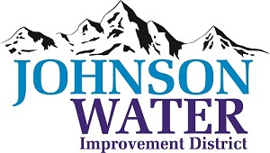
3748 West Highway 87
Roosevelt, UT 84066
Phone (435) 722-2620
August 20, 2026

SUBJECT: Regular Board Meeting

The Board Meeting is Thursday, August 20, 2026 @ 6:30 pm.
Agenda:

- Minutes ~ July 2026
- Financial ~ July 2026
- Bid Opening
  - Pipeline bids
  - Tank bids
- Appointments:
  - East Duchesne Board
  - Sunrise Engineering
- East System Improvements
- Independence Connector Follow up
- Inspector Discussion
  - Jones & DeMille Engineering

- Additional Personnel Discussion
- New Well Site Discussion
- Cyber Security
- Manager Report
  - Truck replacement
  - Well update
- Old Business:

- Closed Session: Purpose listed in the Utah Code 52-4-205 (1) (d)

