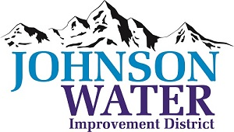
3748 West Highway 87
Roosevelt, UT 84066
Phone (435) 722-2620

November 13, 2025

SUBJECT: Work Meeting

The Work Meeting is Tuesday, November 18th @6:00 p.m.

Agenda:

- Pre Budget Meeting
  - Sunrise Engineering~ report on construction
  - FourPoint ~ Clay Park upgrade water connection

- Old Business:

- Closed Session: Purpose listed in the Utah Code 52-4-205 (1) (d)

