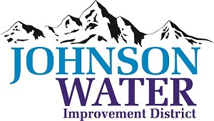
3748 West Highway 87
Roosevelt, UT 84066
Phone (435) 722-2620
July 16, 2026

SUBJECT: Regular Board Meeting and Public Hearing

The Board Meeting is Thursday, July 16, 2026 @ 6:30 pm.
Agenda:
- Public Hearing
- Public input on Rate Increases and dormant meter fees.
- Public input on Master Plan
- Public comments
Close Public Hearing

- Minutes ~ June 2026
- Minutes ~ Work Meeting June 2026
- Financial ~ June 2026

- Wayne Robb – Lost Crops
- Appointments:
  - Sunrise Engineering
- East System Improvements
- Independence Connector Follow up
  - Jones & DeMille Engineering
- Ioka update

  - Wayne Miles
- Waterline extension

- Mini Excavator – Lead and Copper

- Manager Report:
  - Contracts
  - Update on Projects
  - Well Update
  - Inspector discussion
- Old Business:

- Closed Session: Purpose listed in the Utah Code 52-4-205 (1) (d)

