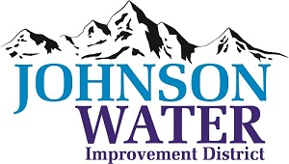
3748 West Highway 87
Roosevelt, UT 84066
Phone (435) 722-2620

June 29, 2026

SUBJECT: Work Meeting

The Work Meeting is Monday, June 29th @10:00 A.M.

Agenda:

- Pre-Qualification
  - Prequalification for East System Improvement Project Water Line
  - Prequalification for East System Improvement Project Tank

- Old Business:

- Closed Session: Purpose listed in the Utah Code 52-4-205 (1) (d)

