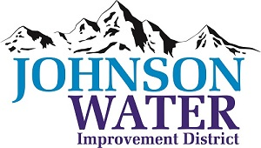
3748 West Highway 87
Roosevelt, UT 84066
Phone (435) 722-2620

October 13, 2025

SUBJECT: Work Meeting

The Work Meeting is Tuesday, October 14th @6:00 p.m.

Agenda:

- Policies update

- Pleasant Valley Connector Line

- Interviewed Candidates

- The Lead/Copper Money

- Old Business:

- Closed Session: Purpose listed in the Utah Code 52-4-205 (1) (d)

