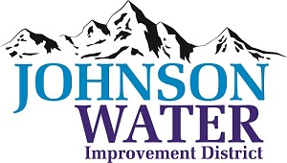
3748 West Highway 87
Roosevelt, UT 84066
Phone (435) 722-2620
September 17, 2026

SUBJECT: Regular Board Meeting and Public Hearing

The Board Meeting is Thursday, September 17, 2026 @ 6:30 pm.
Agenda:
- Public Hearing
- Public input on Loan Application for Ioka Area Water Line Replacement.
- Public comments
- Close Public Hearing

Board Meeting:
- Minutes ~ August 2026
- Financial ~ August 2026
- Appointments:
  - Sunrise Engineering
- East System Improvements
- Independence Connector Follow up
- Inspector Discussion

  - Jones & DeMille Engineering

- Additional Personnel Discussion
- New Well Discussion
- Manager Report
  - Truck replacement
  - Well update
- Old Business:

- Closed Session: Purpose listed in the Utah Code 52-4-205 (1) (d)

